Group Facilitator:
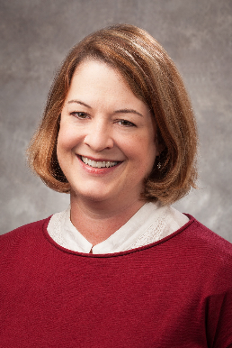
Heidi Beckman, Ph.D.

Dr. Beckman is a clinical psychologist who has worked as a clinician, consultant, supervisor, and researcher in a variety of medical settings. She is dedicated to helping medical patients cope creatively with chronic pain, injuries, and illness. Her interests include working with individuals on mind-body interactions; health-related habit change; and finding hope, meaning, and resilience in the midst of physical suffering. She uses treatment modalities such as cognitive-behavior therapy, motivational approaches, and mindfulness-based approaches.



LIVING WITH WHOLENESS AND VITALITY IN THE CONTEXT OF CHRONIC ILLNESS

A group offered at the
Deming Way Behavioral Health Clinic
2275 Deming Way
Suite 180
Middleton, Wisconsin

Tuesdays 2:30 PM to 4:30 PM
Beginning September 17, 2019
This group is designed for individuals who already know the “basics” of coping with chronic illness or have already completed an introductory-level group of this kind in the past.
The group is designed to help you continue to:
-Improve your motivation for good self-care
-Increase your acceptance of illness and changes in your functioning
-Reconnect with activities that provide meaning and purpose
About the group:
-The group meets for 120 minutes once a week.
-Interested individuals are asked to commit to the full twelve sessions, with the understanding that sometimes illness or life schedules require a person to miss a week or two.
-Maximum number of participants is 10.
-Interested individuals should call the Behavioral Health line (608-233-3575) to schedule an initial one-on-one interview with Dr. Beckman. During the interview, Dr. Beckman will gather background information, answer any questions about the group, and help patients establish what they would like to work on over the course of the group.
-Sessions are billed to insurance under the Health and Behavior codes. Patients should call their insurance company to check on what benefits they have available through their coverage.

September 17, 2019 Session 1: Befriending the self
September 24, 2019 Session 2: Using your neural activity in your favor
October 1, 2019 Session 3: Patricia Fennell’s “phases of chronic illness” model
October 8, 2019 Session 4: Acceptance
October 15, 2019 Session 5: Enjoying life
October 22, 2019 NO GROUP THIS WEEK
October 29, 2019 Session 6: Invisible illness and interacting with the public
November 5, 2019 Session 7: Managing fears of the future
November 12, 2019 Session 8: Vitality
November 19, 2019 Session 9: Gratitude
November 26, 2019 Session 10: Happiness
December 3, 2019 Session 11: Wholeness
December 10, 2019 Session 12: Maintenance

